Business Question and Visualization Report

|  |  |
| --- | --- |
| Date | 17 June 2024 |
| Project Title | Global Malnutrition Trends: A Power BI Analysis (1983-2019) |
| Maximum Marks | 5 Marks |

# Visualization Development Summary

Visualization development refers to the process of creating graphical representations of data to facilitate understanding, analysis, and decision-making. The goal is to transform complex datasets into visual formats that are easy to interpret, enabling users to gain insights and make informed decisions. Visualization development involves selecting appropriate visual elements, designing layouts, and using interactive features to enhance the user experience. This process is commonly associated with data visualization tools and platforms, and it plays a crucial role in business intelligence, analytics, and reporting.

**Business Questions and Visualizations**

# What is the total number of under-five children surveyed?

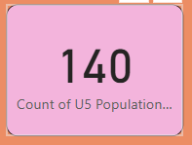**Visualization:** Card displaying the total U5 population

# How many individuals in the dataset are underweight?

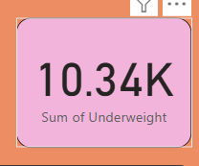**Visualization:** Card visualization showing underweight individuals

# What is the total survey sample size used in the analysis?

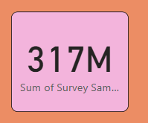**Visualization:** Card visualization for total survey sample

# How does the average stunting rate vary across income classifications?

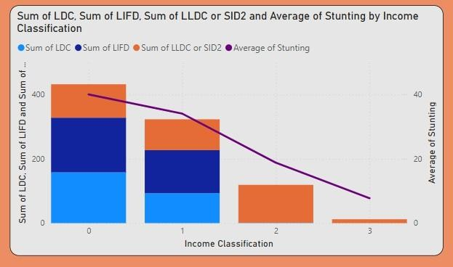**Visualization:** Line and stacked column chart showing stunting and classifications

# What is the overweight population distribution across countries?

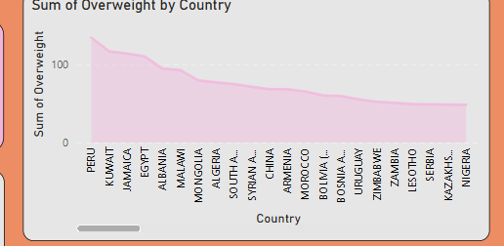**Visualization:** Line/ribbon chart showing overweight individuals by country

# Which income classification has the highest overweight and underweight population?

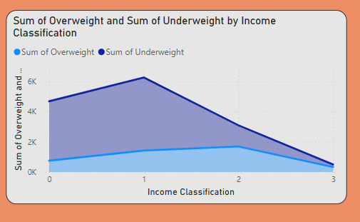**Visualization:** Area chart or stacked line chart comparing both by classification

# Which country has the highest number of overweight children?

**PERU**

**Visualization:** Line chart with overweight population by country

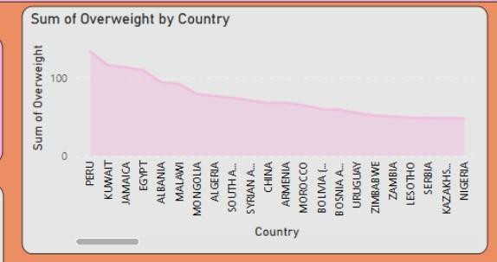

# What is the overall sum of income classification values in the dataset?

**Visualization:** Gauge card showing the income classification sum

